# Webinar 4_A

**Learning Objectives**

* Events (Procedures) – setup, draw, keyPressed
* animation
* Conditional statements : if
* Procedures – modularisation
* Provide solution can be adapted for you Pong game.

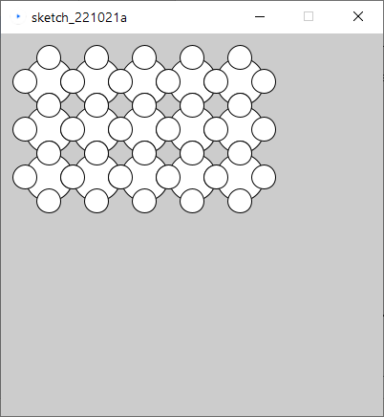

**Code below was a bug ridden attempt at producing the pattern above – fix it and improve it’s readability.**

void setup()

{

size(400,400);

Pattern(50,50.5,3);

}

void pattern(int x,int y, int s, int r, int c

[

int left = x;

for(int i=0,i<c,i++);

{

for(int j=0;j<r;j++)

{

int half=s/2;

ellipse(x,y, s,s);

eclipse(x+half,y, half,half);

ellipse(x-half,y, hal,half);

ellipse(x,y+half, half);

ellipse(x,y-half, half,half);

x=x+s

}

x=left;

y=y+s;

}

**Ex 2 Produce this pattern**

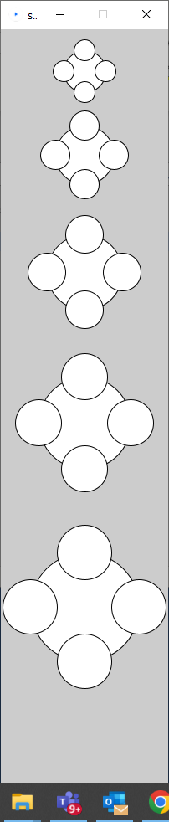

**Some examples**

[**https://processing.org/examples/radialgradient.html**](https://processing.org/examples/radialgradient.html)

[**https://processing.org/examples/tree.html**](https://processing.org/examples/tree.html)